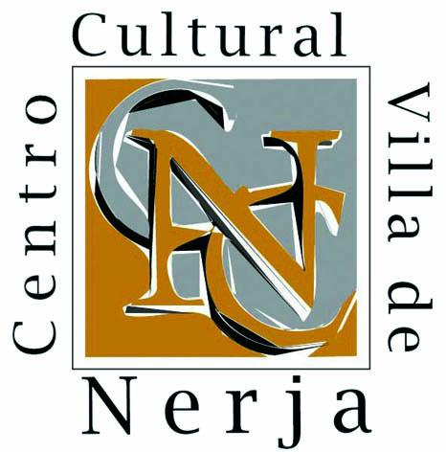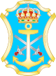
CIF G93013514
NERJA HISTORY GROUP 2024-25 SEASON
For anyone interested in Spanish History
Meetings are held in the Cultural Centre, C/Granada,Nerja
Starting 11.00 am & finishing at 13.00 approx.
It is our policy not to give refunds for missed trips for which you have already paid

MEETING DATES COACH TRIPS
Talks and Guest Speakers: Dates & Destinations:
Friday 4 th October Friday 11 th October
Public and Private Lives: The Siege of Madrid 1936-39 Museo de Aceite - tastings of
By Patrick McQuaile local produce

November 8th *Thursday November 14th
The History of Medicine in Spain “Madinat Ballish” historic tour
By Dr Rob Feneck of Al-Andalus in Velez Malaga

December Friday December
No meeting Possibly Malaga Lights
2025
Friday January 10th Friday January 17th
The British infuence in mining in Andalucia 18th-20th C Valdes & Moclinejo
By Nick Nutter

Friday February 7th Friday February 14th
The Bilbao Effect Alcala la Real
By Rafa Anderson

Friday March 7th Friday March 14th
The University Campus of Cartuja (Granada): History & Archaelogy in Granada
a history of 5,000 years by Elena Sanchez with Elena Sanchez

Friday April 11th April 18th
The Fontainebleu & its role in tourist development in Nerja TBD
By Paul S Bradley

I am planning a January jaunt to Cadiz “ Historic Sights and Gastronomic Delights”

Christina Sinclair, Co-ordinator: 687 602 057
Email: nerjahistorygroup@yahoo.com
www.nerjahistorygroup.com

